**Web Programming Lab**

**IPS-1**

Name : Rohit Sinha

Registration Number: 22BCE5007

**Code(For Page):-**

<html>

    <head>

        <title>Features Of HTML</title>

        <!---

            Refresh Every 5 seconds its commented cuz its annoying

            <meta http-equiv="refresh" content="5">

        --->

    </head>

    <body bgcolor = "#FFD3B9" background="./assets/backgroundImg1.png">

        <center><h2>A simple sample <s>dynamic</s> <u>static</u> web page</h2></center>

        <center>

            <p>

                <br>

                <a href="https://www.bing.com/images/search?view=detailV2&ccid=Y7bm664P&id=2F034B7B1D5BE10B35BA1613E149424507914B3D&thid=OIP.Y7bm664PLAjQLrFq-TS8GwHaHa&mediaurl=https%3a%2f%2flogodix.com%2flogo%2f470374.jpg&exph=626&expw=626&q=html+logo&simid=607989656911702841&FORM=IRPRST&ck=FE352C2201B362560D5268B3CE10D6D4&selectedIndex=21&itb=0">

                    <figure>

                        <p>

                            <img src="./assets/htmlLogo.png ">

                            <br>

                            <figcaption>Figure Caption</figcaption>

                        </p>

                    </figure>

                </a>

                <b>By Rohit Sinha</b>

            </p>

        </center>

        <center><h2><u>Demonstrate a few HTML features</u></h2></center>

        <hr color = "black">

        <p>

            <br>

            <justify>

                <font face = "Courier New">

                HTML is really a very simple language.It consists of ordinary text,

                with commands are enclosed by &ldquo;&lt;&rdquo; and &ldquo;&gt;&rdquo;

                characters, or between an &ldquo;&amp;&rdquo; and a &ldquo;&semi;&rdquo;

                (for example &lt;html&gt;). You don't really need to know much HTML to

                create a page, because you can copy bits from pages that do what you want,

                then change the text! This page shows on the left as it appears in your

                browser, and the corresponding HTML code appears on the right. The HTML

                commands are linked to the explainations of what they do.

            </font>

            </justify>

            <br>

            <br>

            <br>

            <marquee direction = "left"><b>Line Breaks</b></marquee>

            <br>

            <br>

            HTML doesn't usually use line breaks for ordinary text.A white space of any size is treated

            as a single space.The code type of format can also be dont in html for example

            <br>

            <br>

            <br>

            <font face = "Courier New">

                #include &lt;stdio.h&gt;<br>

                void main()<br>

                {<br>

                    cout &lt;&lt; &ldquo;This is a simple program&rdquo;&semi;<br>

                }<br>

            </font>

            <br>

            If you want to put muliple spaces, then you can use non breaking space entity by multiple times.For ex,I would like to use 3 more blank &nbsp;&nbsp;&nbsp; spaces here. If you want to put a line break at a particular place, you can use the &ldquo;&lt;BR&gt;&rdquo; command, or, for a paragraph break, the &ldquo;&lt;P&gt;&rdquo; command, which will insert a blank line. You can also use some extended text formatting features such as superscript,subscript and mark features like this

            <br>

            <br>

            1<sup>st</sup>,2<sub>nd</sub> and <b><i>emphasized format features</i></b>

            <br>

            <br>

            <b>Starting And Stopping Commands</b>

            <br>

            <br>

            <pre>

                Most HTML commands come in pairs: for example, "&lt;H4&gt;" marks the beginning of a size 4 heading,

and "/&lt;H4&gt;" marks the end of it. The closing command is always the same as the opening command, except for the addition of

    the "/".

            </pre>

        </p>

        <center>

            <h1>This is a size "1" heading</h1>

        </center>

        <h2>This is a size "2" heading</h2>

        <h3 align="right">This is a size "3" heading</h3>

        <center>

            <p>

                <video width="320" height="240" controls>

                    <source src="./assets/oneStream.mp4" type="video/mp4">

                </video>

                <br>

                <br>

                <b>Copyright &copy;, by <a href="#">Rohit Sinha</a><sup>TM</sup></b>

                <br>

                <justify>

                    The objective of the equation is to use one a two &delta; three &gamma;<br>

                    If you would like to make a link or bookmark to this page, the URL is:

                </justify><br>

                <a href="https://azaken1248.github.io/WebProgramming-IPS-2-Part-1-/">https://azaken1248.github.io/WebProgramming-IPS-2-Part-1-/</a>

            </p>

        </center>

    </body>

</html>

**Output(For Page):-**

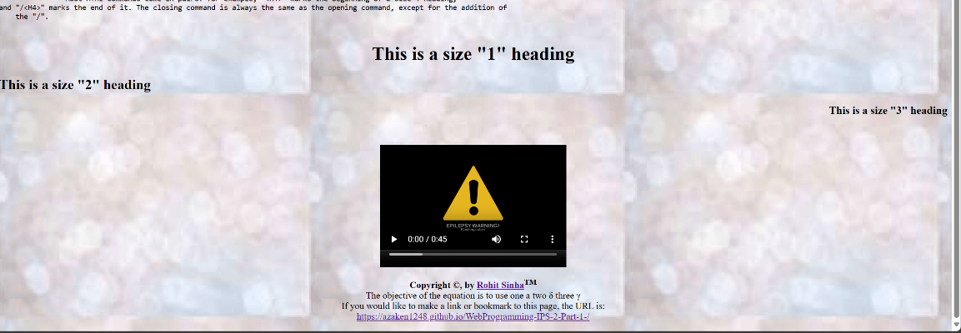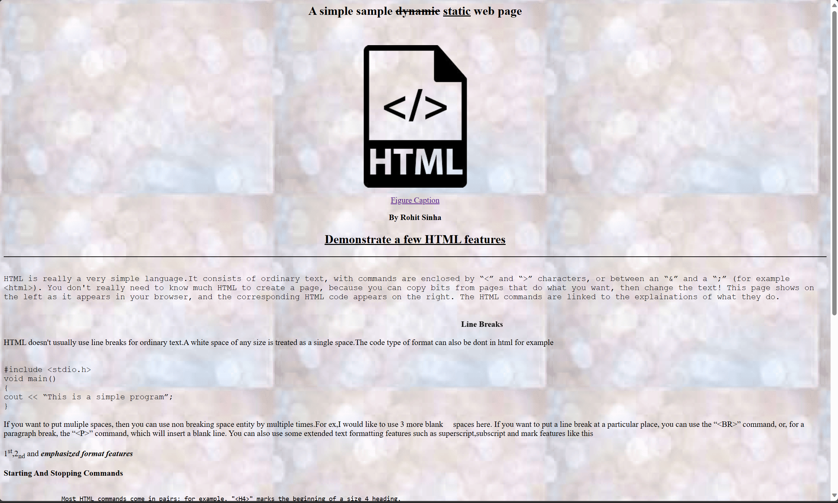

**Code(For Table):-**

<html>

    <head>

        <title>Tables In HTML</title>

    </head>

    <body>

        <center>

            <table border="1px" cellpadding="0%">

                <caption>Here is the table caption</caption>

                <tr>

                    <td rowspan = "2"><img src="./assets/htmlLogo.png" width="150px"></td>

                    <td colspan="5">

                        <center>

                            <p>

                                <h1>XML</h1>

                                <br><br><br>

                                <b>Approximation</b>

                                <br>

                                &nbsp;

                            </p>

                        </center>

                    </td>

                </tr>

                <tr>

                    <td><center><b># of languages</b></center></td>

                    <td width="180px"><center><b>Regions</b></center></td>

                    <td><center><b>What?</b></center></td>

                    <td><b>How are you?</b></td>

                </tr>

                <tr>

                    <td><center><b>First Country</b></center></td>

                    <td>2</td>

                    <td>India</td>

                    <td rowspan="2">Nothing</td>

                    <td rowspan="2">Fine</td>

                </tr>

                <tr>

                    <td><center><b>Second Country</b></center></td>

                    <td>1</td>

                    <td>United States Of America</td>

                </tr>

            </table>

        </center>

    </body>

</html>

**Output(For Table):-**

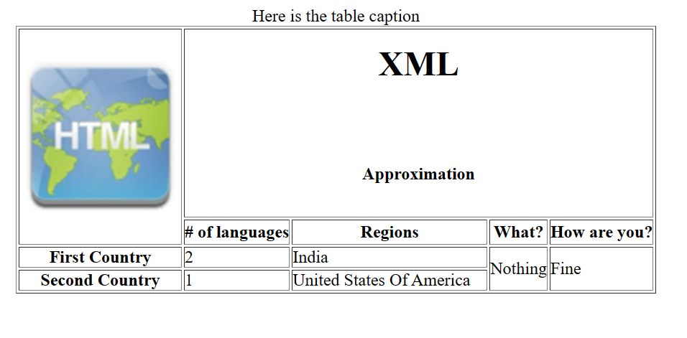

**Pages Link:-**

**Page ->** [**https://azaken1248.github.io/WebProgramming-IPS-2-Part-1-/**](https://azaken1248.github.io/WebProgramming-IPS-2-Part-1-/)

**Table ->** [**https://azaken1248.github.io/WebProgramming-IPS-2-Part-2-/**](https://azaken1248.github.io/WebProgramming-IPS-2-Part-2-/)